When and how to correctly prune your plants
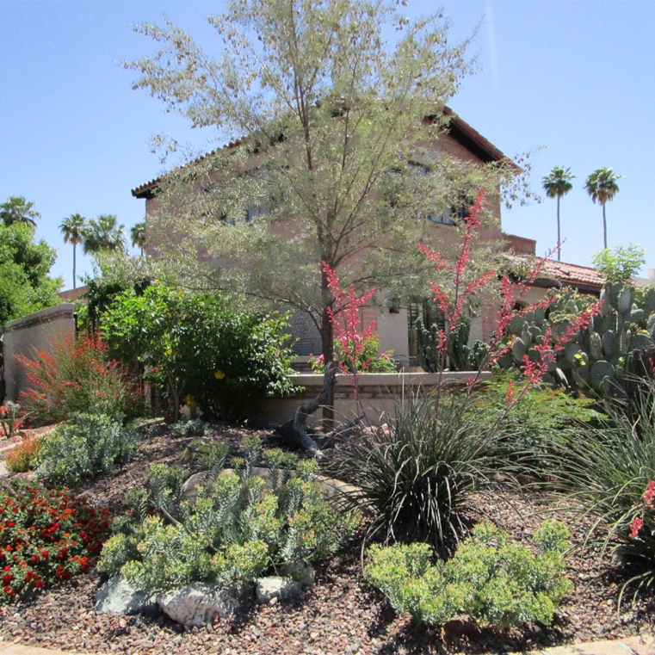
Many will be eager to get outdoors and tend to their trees and plants as the weather warms. While we all want our yards to look their best, many of us are guilty of over-pruning, which can cause unintended side effects like increasing your plants' watering needs.

Regular shearing and shaping desert shrubs into geometric shapes, such as balls, squares, or inverted pyramids, weakens these shrubs, detracts from their beauty, and discourages them from flowering, ultimately shortening their lives. So, proper pruning is a must.

If we lived with more humidity and regular doses of rain, shrubs would recover more quickly from regular shearing. But here in the desert, our shrubs cannot handle the stress of over-pruning because they need to survive on sparse resources under the relentless sun and our arid climate. Plus, over-pruning increases their water needs.

It's essential to leave them in their natural form because their leaves make and store food that helps them grow and fight off disease. When gardeners regularly prune leaves and branches, the shrubs use their stored energy to survive and cannot thrive because they live under constant stress. Desert shrubs that are sheared and pruned regularly tend to build shells of small leaves, causing the insides to get dense with woody branches. Eventually, shrubs can't make enough leaves, and woody holes begin to break through the shell. The shrubs struggle, lose their vibrant appearance, and eventually wear out.

Most shrubs familiar to Valley homeowners, such as Texas sage, California rosewood, and creosote, look their best when left alone. They will remain happy with a few inches of careful trimming, including removing their dead and diseased limbs.

Here are instances where pruning is appropriate:
- To remove dead, diseased, or weakened branches
- To keep walkways, driveways, and other high-traffic areas in your yard passable and safe
- To remove branches that rub against each other
- To control or direct growth

The goal is to allow light and air to reach deep inside the shrub. A shrub will grow leaves along every branch instead of a shell of leaves only at the tips. So, if you must prune:
- Take out a maximum of 1/3 of the shrub's older, larger branches.
- Cut the branches at the point where they attach to the plant or at the ground.
- Remove branches that are rubbing against each other

Desert shrubs need to be wider at the base. Bottom branches shade shrubs' roots, maintaining moisture and cooling the soil. When gardeners remove the ground-level branches, they expose the soil to harsh sun and drying.

An ideal desert garden hedge uses various lightly pruned shrubs in a staggered line, similar to the plants scattered along a desert wash. Leave the formal hedges for English gardens and bring a little desert design to your yard.

The watchword for pruning desert-adapted trees and shrubs is WAIT. Typically, there is no need to prune for the first year or two. Plus, leaving growth on lower tree trunks for one to two years results in increased trunk size and strength. Watch your plants during the establishment period, and you will find that most desert-adapted plants and trees have a beautiful natural form that requires little or no pruning.

Find out how and when to prune shrubs of all kinds at the University of Arizona Cooperative Extension, get pruning tips and resources on the Landscaping With Style website, or find a free class available through the AMWUA cities.

For 55 years, the Arizona Municipal Water Users Association has helped protect our member cities' ability to provide their communities with assured, safe, and sustainable water supplies. For more information, visit www.amwua.org.

